**CANTERBURY CRICKET ASSOCIATION 1946-47**

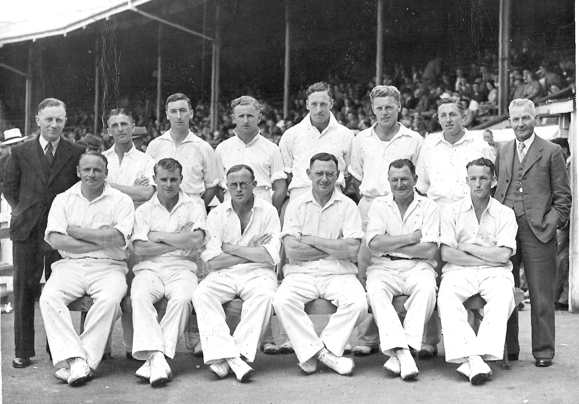

**Back row:** CG Crawford (manager), W Pollitt, AEL Britton, EC Carston, RH Scott, AT Burgess, PAT Small,

RH North (manager)

**Front row:** TB Burtt, FB Smith, WMcD Anderson, IB Cromb, JH Parks, RC Shand